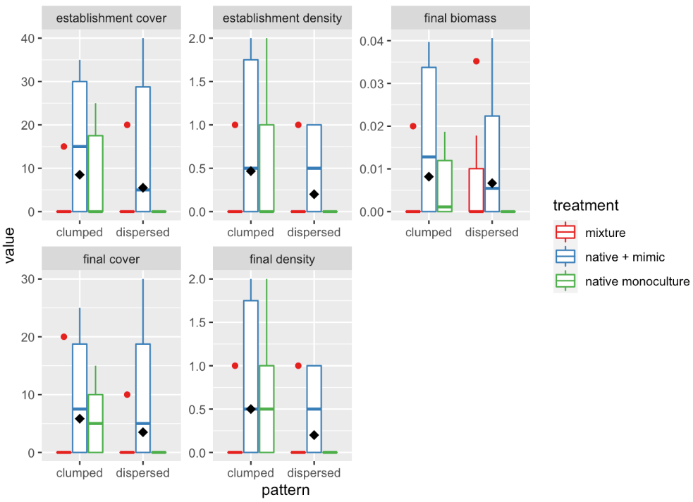**Figure 1.** Boxplots of measures percent cover (establishment and final; %), density (establishment and final census), and final biomass (g) of mixture, native + mimic, and native monoculture treatments comparing two spatial patterns (clumped vs. dispersed). Diamond dots represent the mean. Establishment data was collected at week 4 and final data was collected at week 8.